**LAB MANUAL**

**NAME: MAHBOOB ALI**

**ID NO: BIT-24S-027**

**COURSE: ARTIFICIAL INTELEGENCE (AI)**

**COURSE INS: MA’AM AQSA UMAR**

**LAB NO: 1**

**INTRODUCTION TO PYTHON:**

Python is a beginner-friendly programming language that's easy to learn and use. It’s popular because it has simple, readable code and can be used for many things, like building websites, analyzing data, or creating games. Python works on all major operating systems, like Windows and Mac, and it has many built-in tools (called libraries) to make your work easier.

TASK NO 1: Make 2-2 programs of each datatype**.**

1. **NUMERIC TYPES**

**Integer (int)**

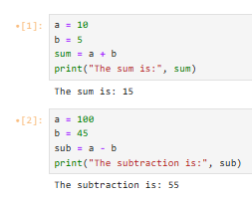



**Floating-point (float)**

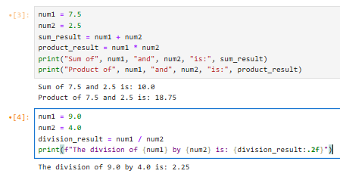

**Complex (complex)**

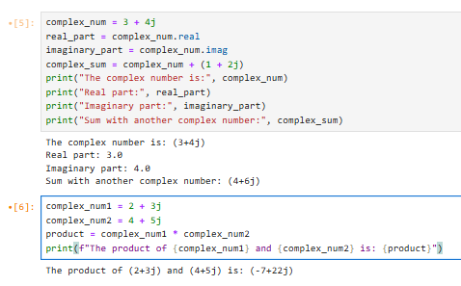

1. **Sequence Types**

**String (str)**

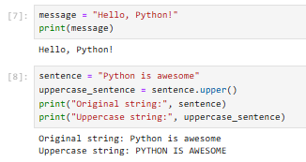

**List (list)**

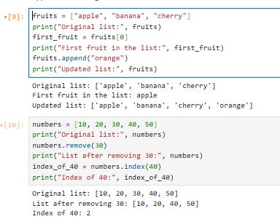

**Tuple (tuple)**

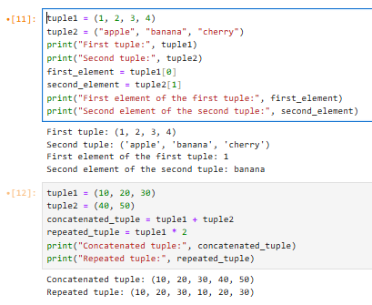

**Range (range)**

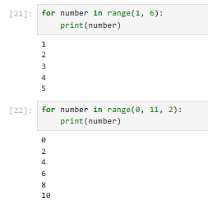

**3. SET TYPES**

**Set (set)**

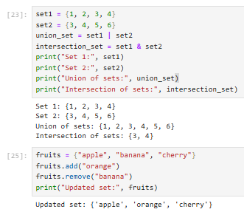

**Frozen Set (frozenset)**

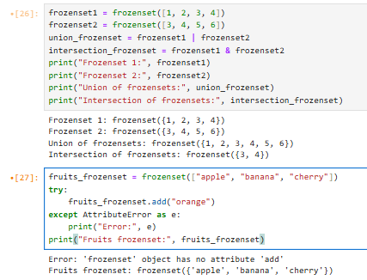

1. **MAPPING TYPE**

**Dictionary (dict)**

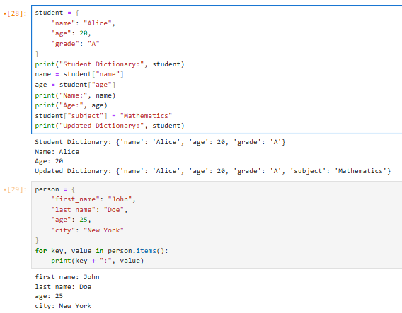

1. **Boolean Type**

**Boolean (bool)**

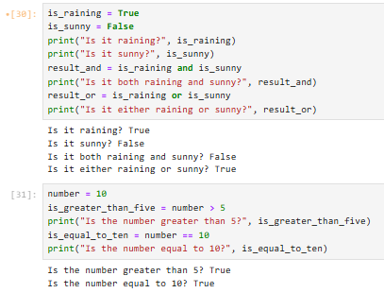

**TASK NO 2: Make up to 5 Shape programs using *.**

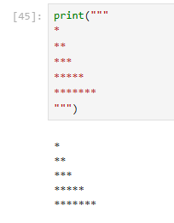

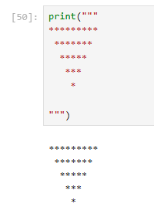

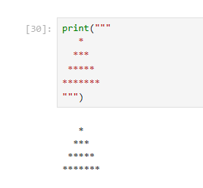

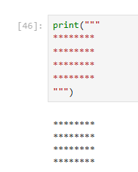

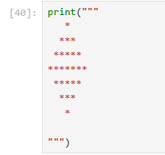

# TASK NO 3: Make same shapes you have made in task 2, using * mutiple by number.

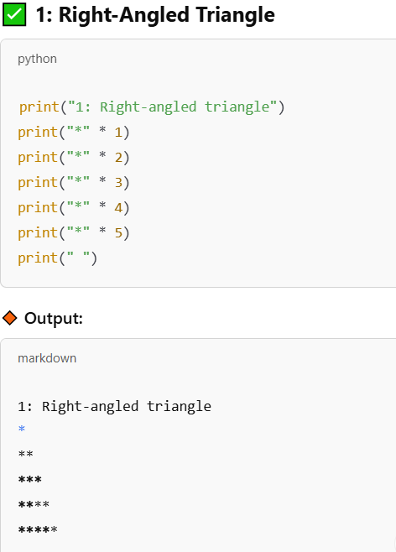

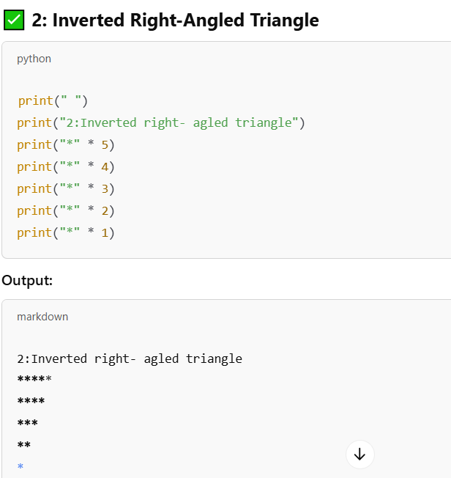

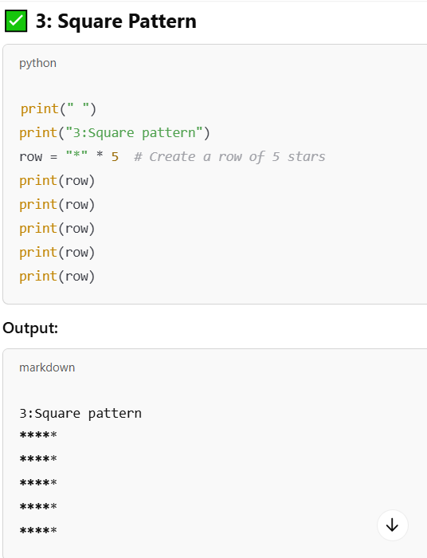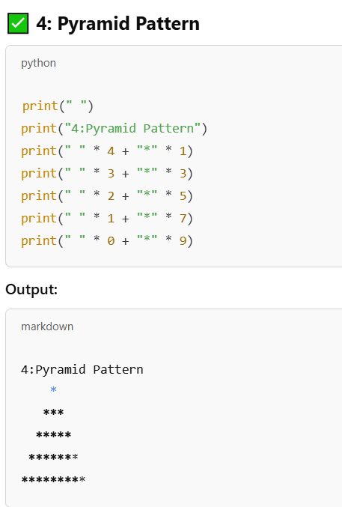

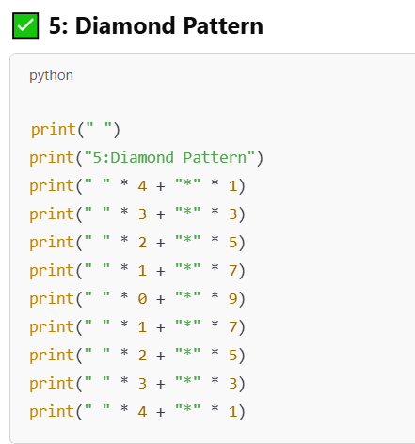

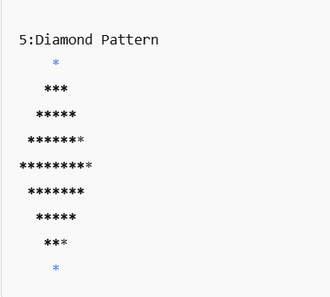

## LAB 02

## Python Looping Tasks

1. **Print numbers from 1 to 10 using a for loop.**

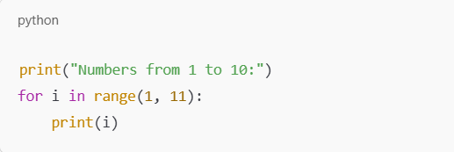

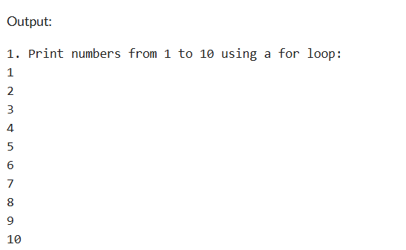

**2.Print all even numbers between 1 and 20 using a while loop.**

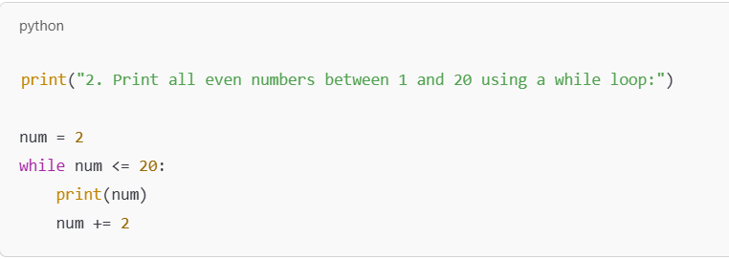

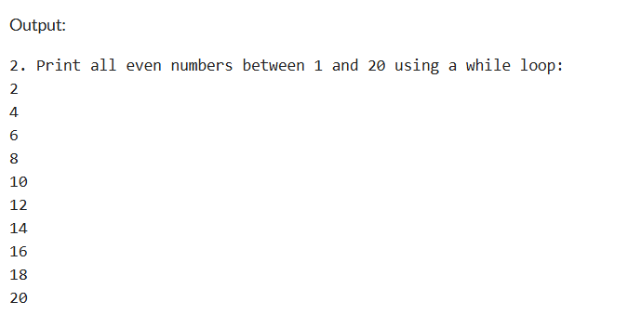

1. **Calculate the sum of numbers from 1 to 100 using a loop.**

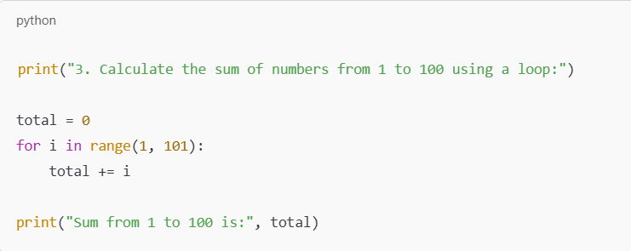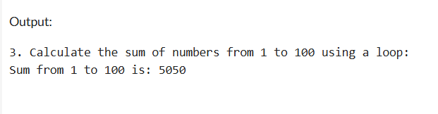

1. **Print the multiplication table of 5 using a loop.**

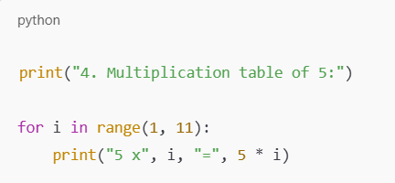

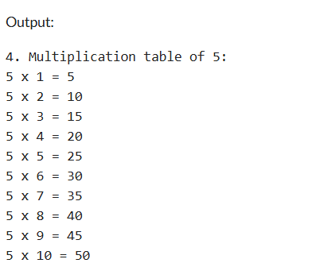

1. **Find the factorial of a given number using a for loop.**

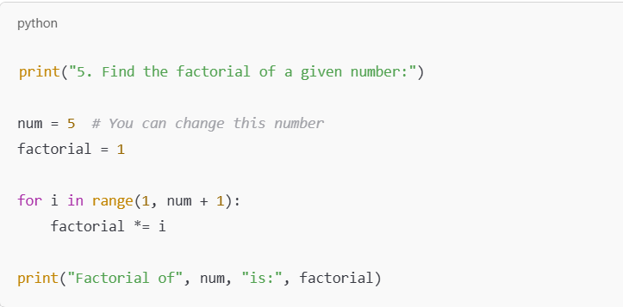

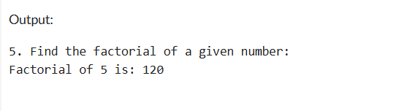

1. **Iterate over a list of fruits and print each item.**

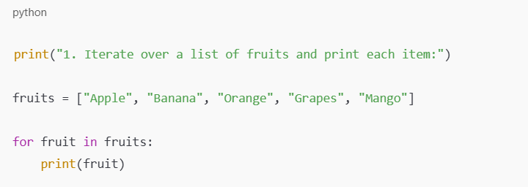

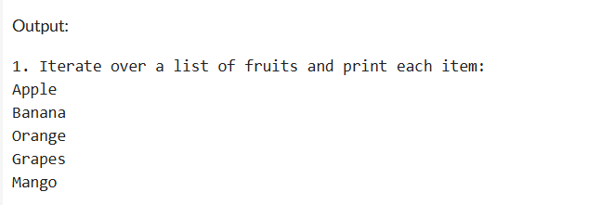

1. **Create a list of numbers and print only the odd numbers using a loop.**

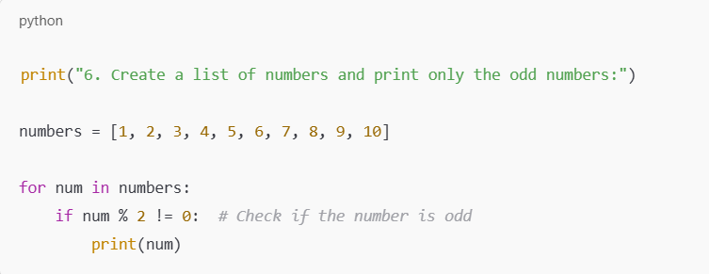

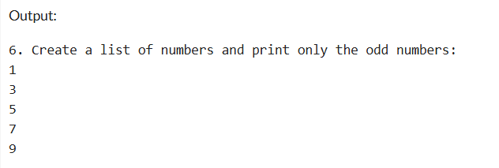

**LAB 03**

**LAB 04**

# Tasks Related to Arithmetic Operators

1. Write a Python program to take two numbers as input and perform all arithmetic operations on them.

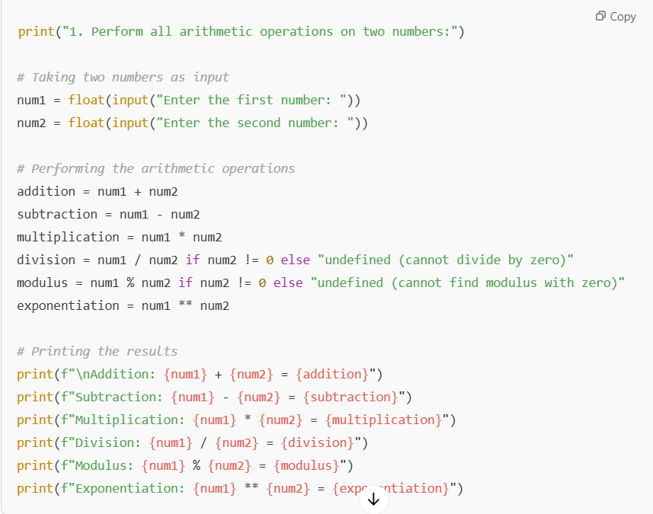

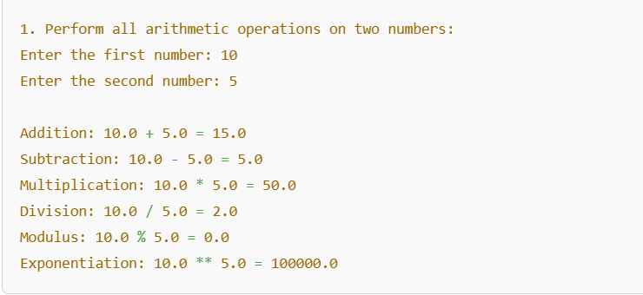

1. Create a function that takes two numbers and returns their sum, difference, product, and quotient.

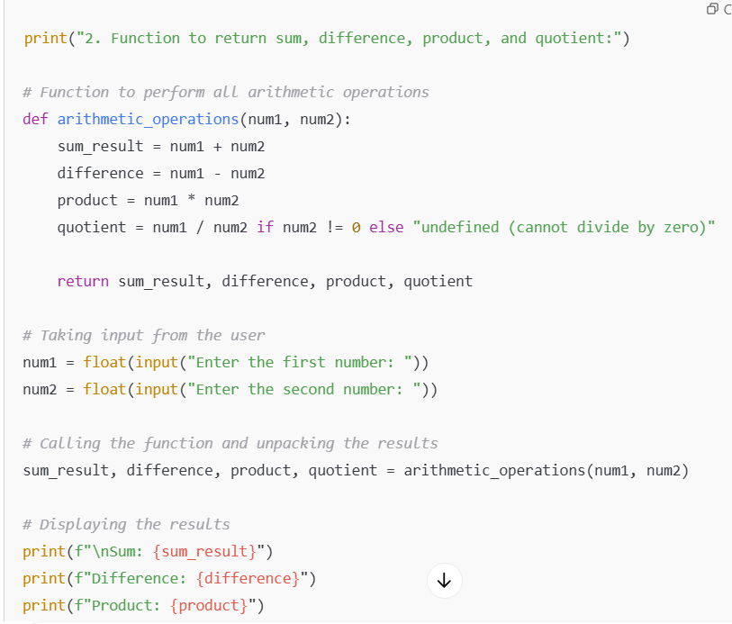

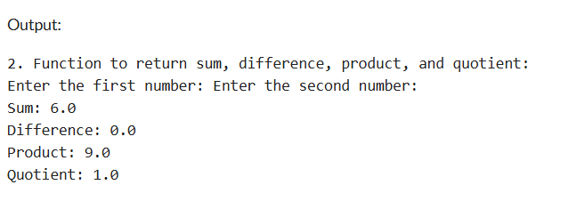

1. Write a Python script to find the remainder when one number is divided by another.

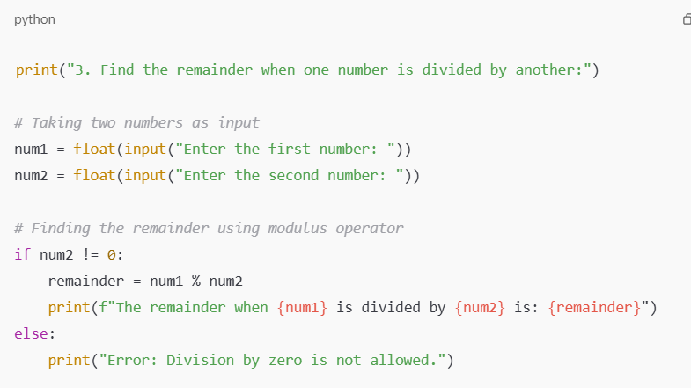

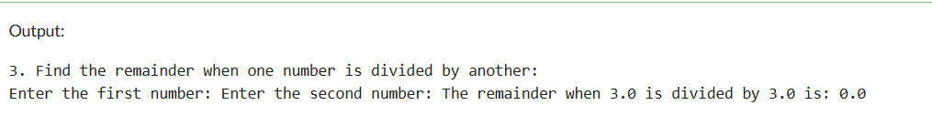

1. Write a program to calculate the area of a circle using the formula: Area = π * r^2.

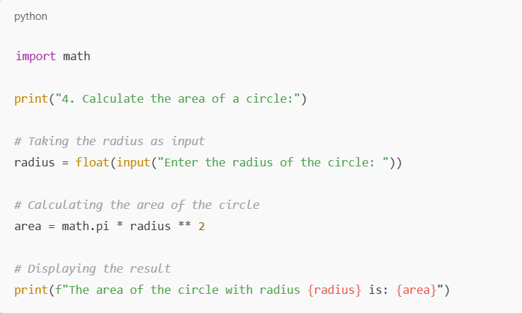

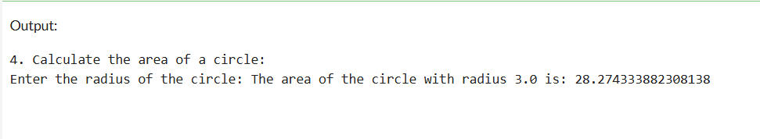

1. Implement a program that takes a number as input and returns its square and cube using exponentiation.

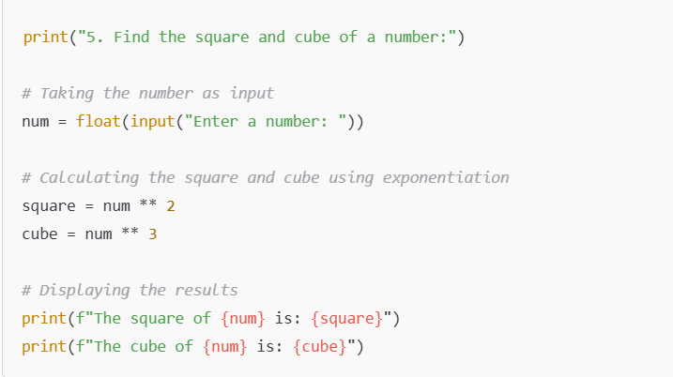

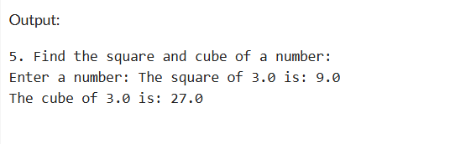

1. Create a simple calculator in Python that allows the user to choose an operation (addition, subtraction, etc.) and inputs two numbers.

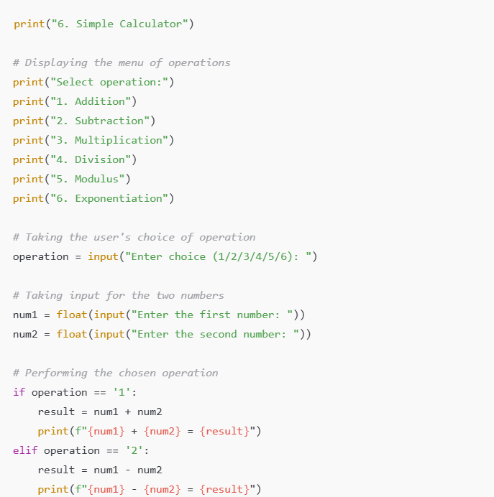

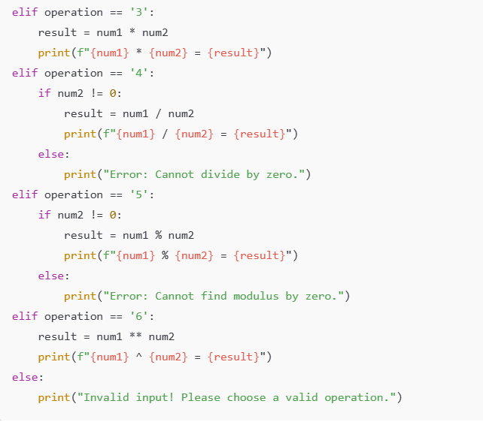

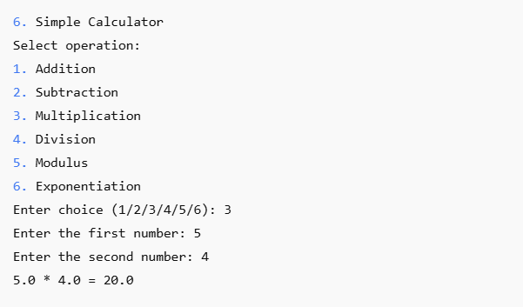

# LAB 05

# Python if and else Statements

1. **Basic Task:** Write a program that checks if a given number is positive, negative, or zero.

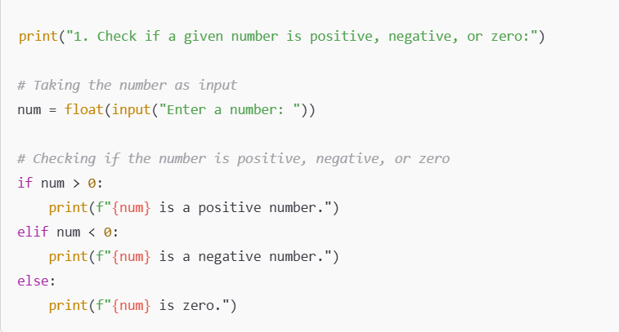

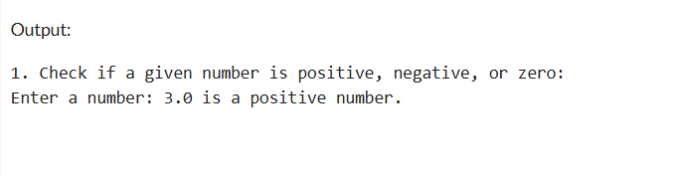

1. **Intermediate Task:** Write a program that takes user input and determines whether it's a even or odd.

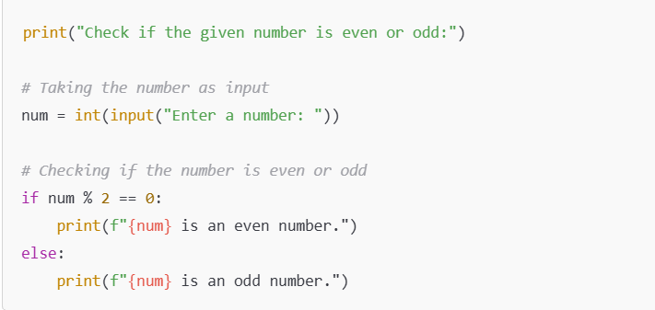

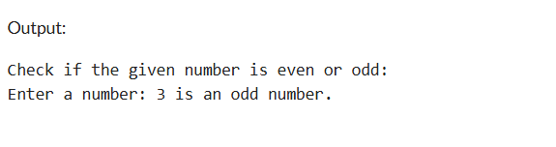

1. **Advanced Task:** Create a program that asks user to print:
   * "Excellent" if marks are above 80
   * "Good" if marks are between 60 and 80
   * "Needs Improvement" if marks are below 60

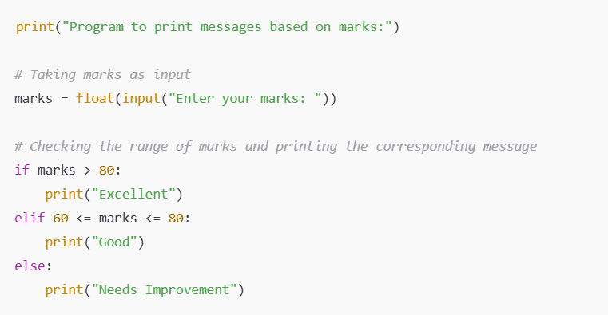

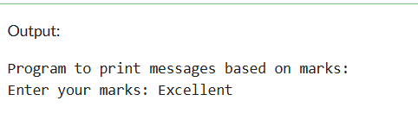

**LAB 06**

# Python for and while Loops

1. **Basic Task:** Write a for loop to print the first 10 natural numbers.

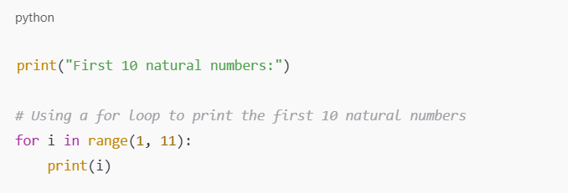

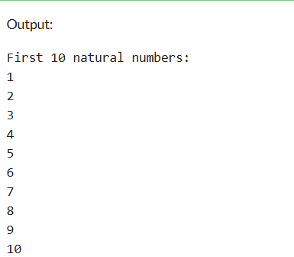

1. **Intermediate Task:** Write a while loop that prints numbers from 10 down to 1.

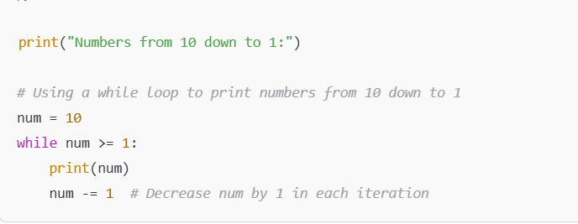

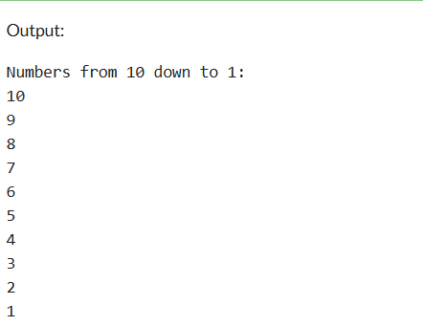

1. **Advanced Task:** Create a program that uses a for loop to iterate over a string and count the number of vowels.

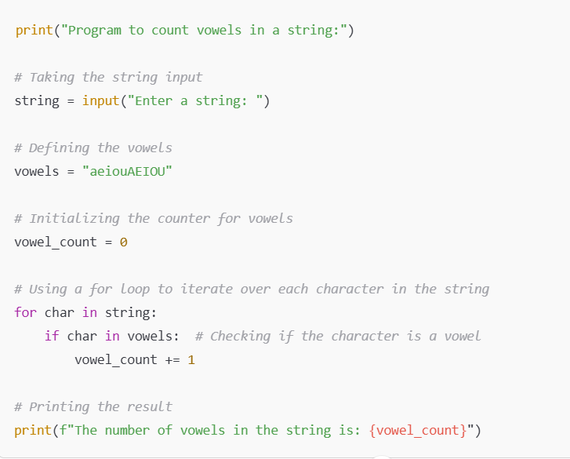

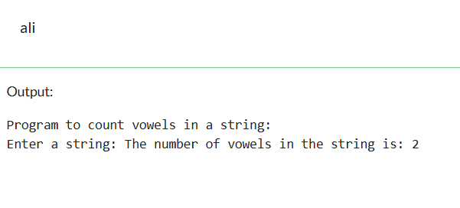

1. **Challenge Task:** Write a program that prints the Fibonacci series up to n terms using a while loop.

